**Lab 6 – REST API**

Login page

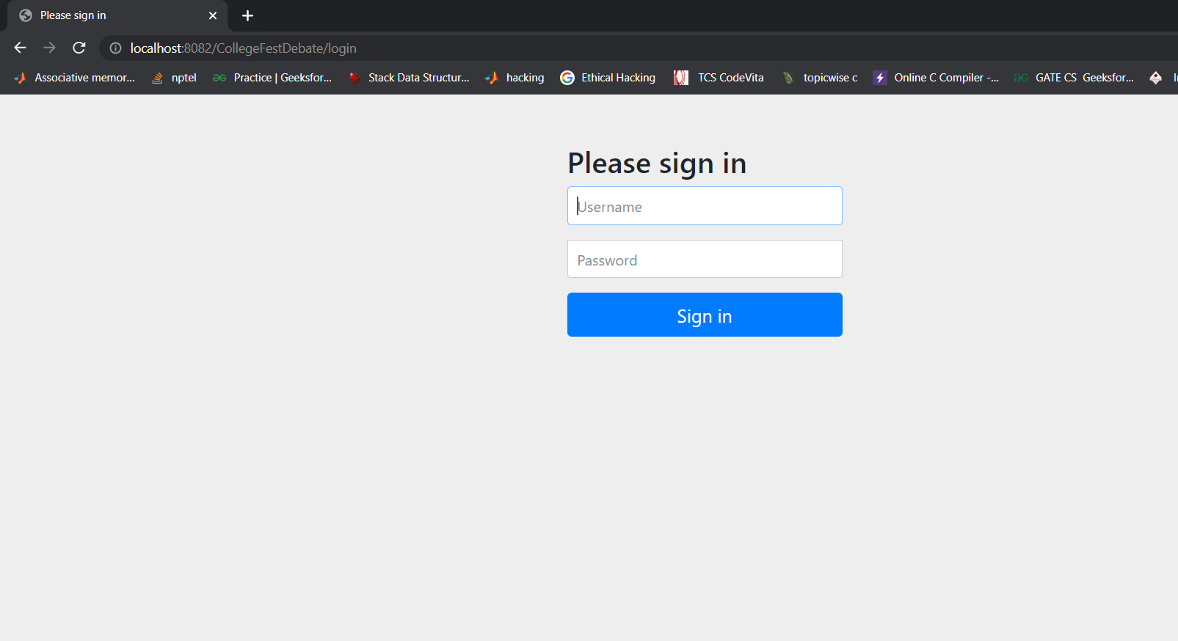

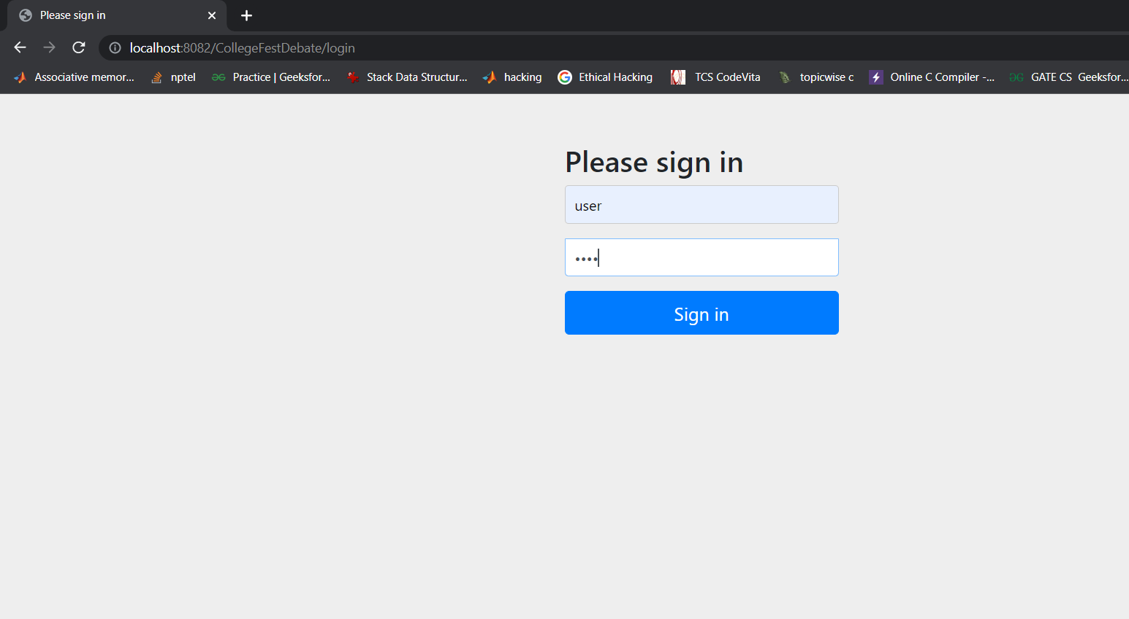

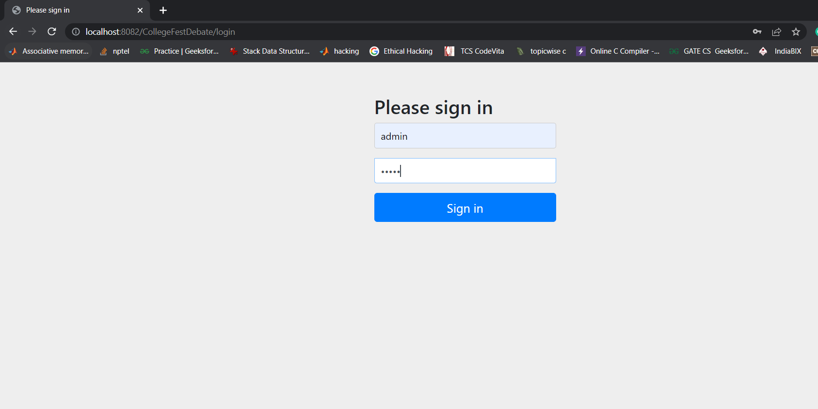

Home page

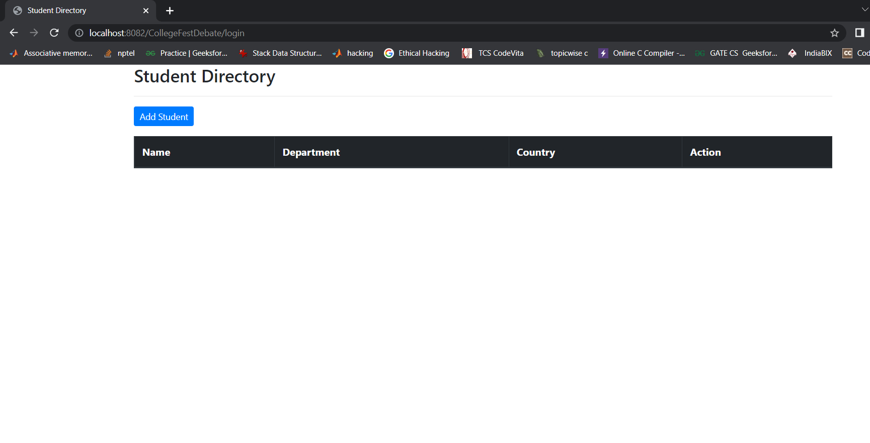

Blank table of student directory.

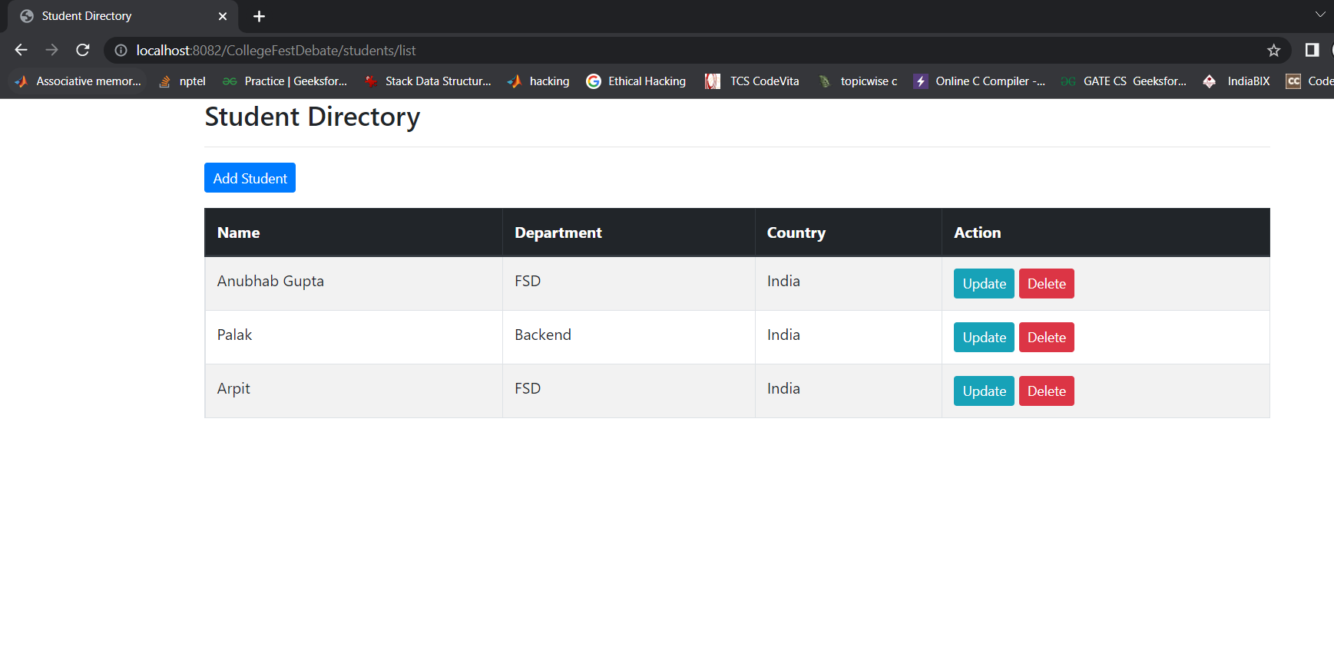

Student directory table with student details like Name, Department, Country and Action. In action we can update or delete student details.

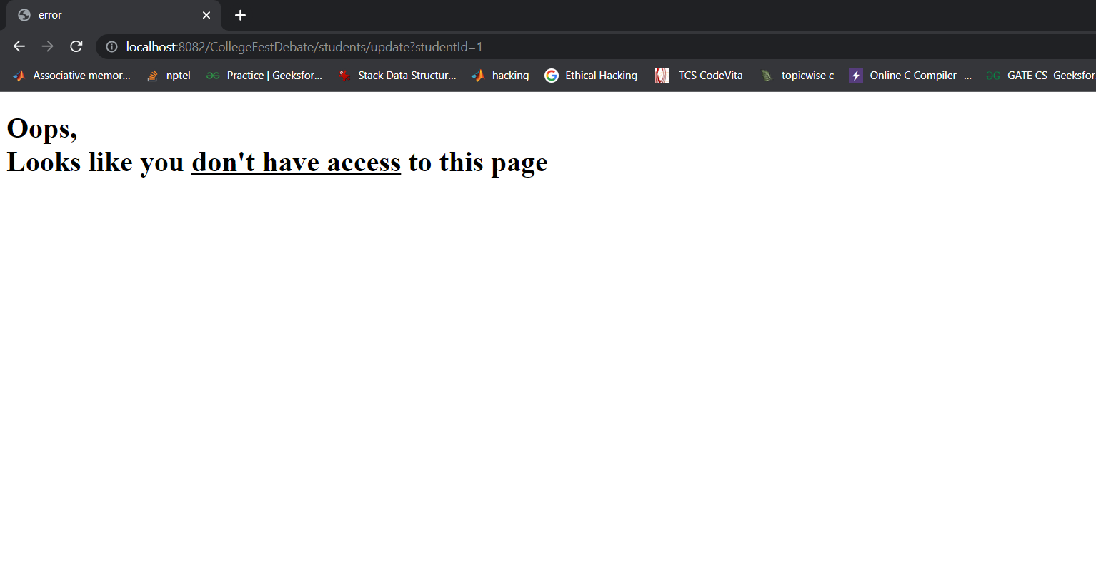

User do not have access to update student details. If user try to update it will show page as shown above.

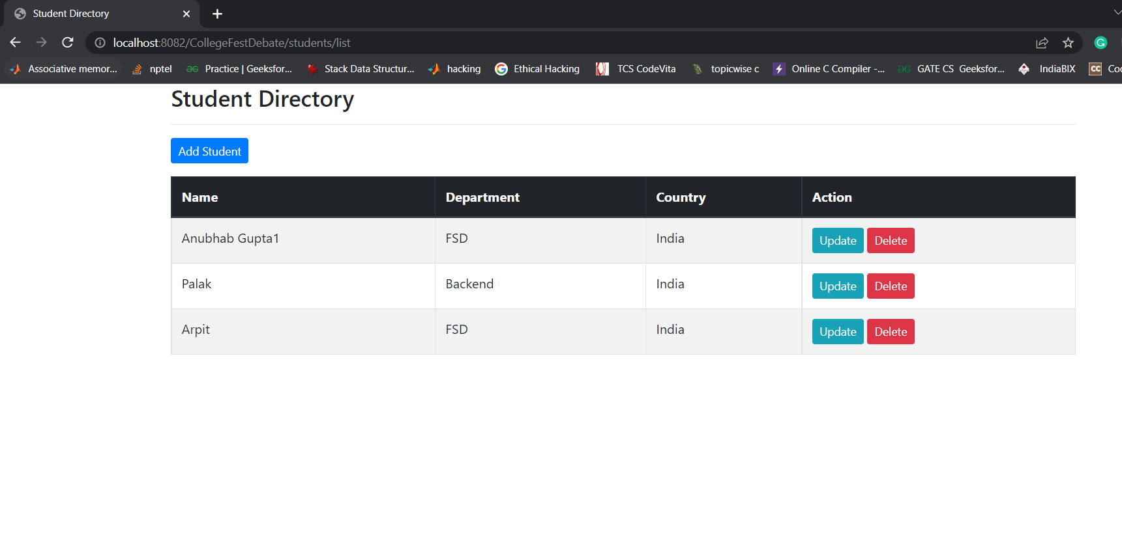

Admin role has access to update student api. Admin can update student details. In above example we change the name of student from “Anubhab Gupta” to “Anubhab Gupta1”.

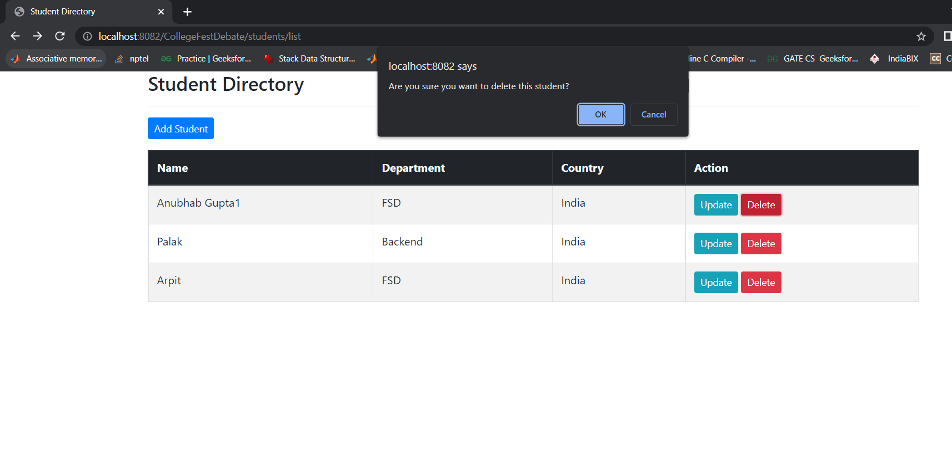

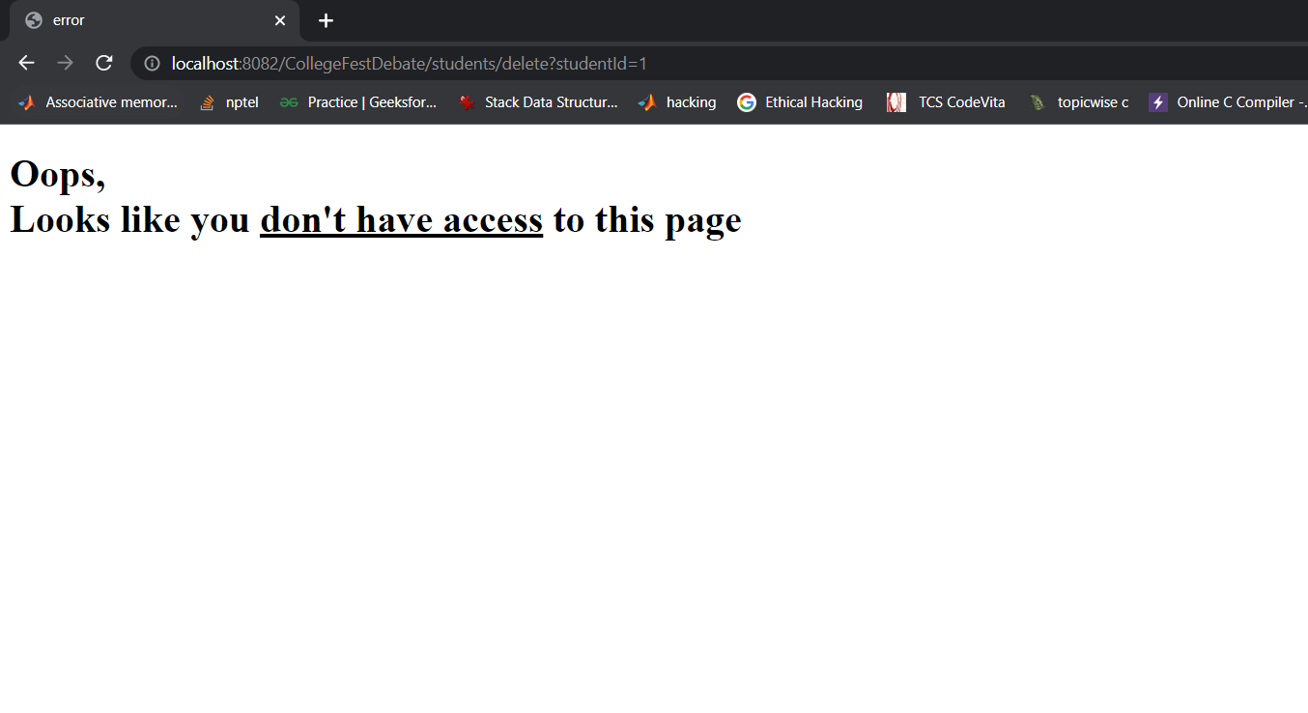

User do not have access to delete student details. If user tries to delete student details it will show above page.

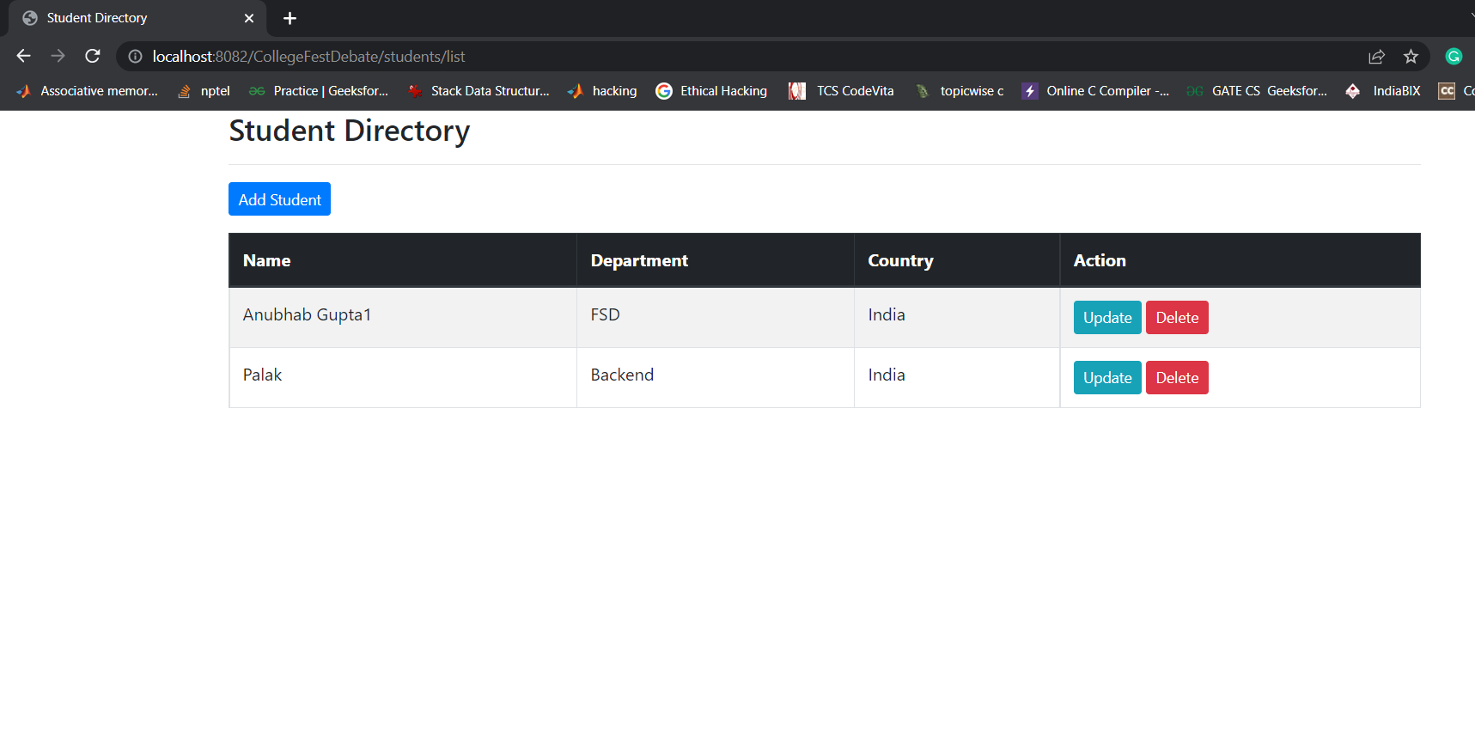

Admin role has access to delete the student record. As we can see admin has deleted Arpit’s record from student directory table as shown above.